Marta gets her first job after college doing fashion design. For people starting out the averge salary is normally distributed with an average of 42000€ and a standard deviation of $5000.
She wants to know:
- She wants to make between €40,000 and €50,000 – what percent make in that range?
- Her first offer was for €44,000, find what percentile that would be?
- What do the top 5% make?

Kevin needs to get a new car. He is looking at Ford F150s. Online it says the average price for an older truck is $7,000 with a standard deviation of $1400.

Find:

- He wants to pays under $6,000, what percent pay this little?
- He is going to get a loan for $5000 - $7000? What percent of the trucks are in that range?
- What do the middle 50% pay?

Husna is going to apply to college. On the SATs, the average at the school she wants to go to is 1140 and is normally distributed with standard deviation of 80.

- Her first time she scored 1190, what percentile at the school would that be?
- If she can score in the top 10 percent, she will get a small scholarship – what score would she need to get for that?
- What percent of the students get between 1000 and 1200?

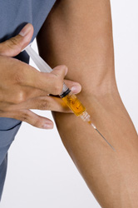
Kason wants to be in sports medicine. He has to drug test athletes to see if they are taking performance enhancing drugs. Some athletes take testerone to increase performance. An average male has testerone levels of 120 with a standard deviation of 13.
- He is testing athletes and finds an athlete has a level of 145, find his percentile?
- If an athlete is in the top 1%, he is accused of cheating, what is the cutoff for that?
- An athlete outside of the normal range is usually retested. Those outside 110 – 130 are retested, find what percent are retested?
Nynavae loves to sleep. The average person sleeps 7.5 hours a night with a standard deviation of 1.75 hours. It is normally distributed.

- Last night she slept 4 hours, Find the percent of people she slept more than?
- Her doctor says she should get between 7 and 9 hours. What percent of people sleep that much?
- She wants to improve her sleep so that she sleep more than 75% of people, how many hours does that mean?

Juliana gets a job at Amatos and she gets tips. On an average night, she will make $25 in tips and it varies on average (standard deviation) by $8. It is normally distributed.
- She wants to make $30 or more in tips, what’s the chance of that happening?
- On days she wears a Patriots shirt, she makes between $30 and $35, what percent of the time should that happen?
- Tonight she made more than 60% of the time, how much did she make?

Answer sheet: NAMES: _____________ AND ________________
Juliana
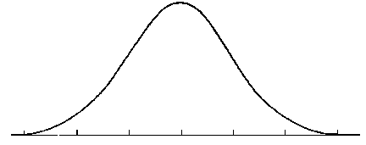
Husna
Marta

Kevin

Kason
Nynavae

